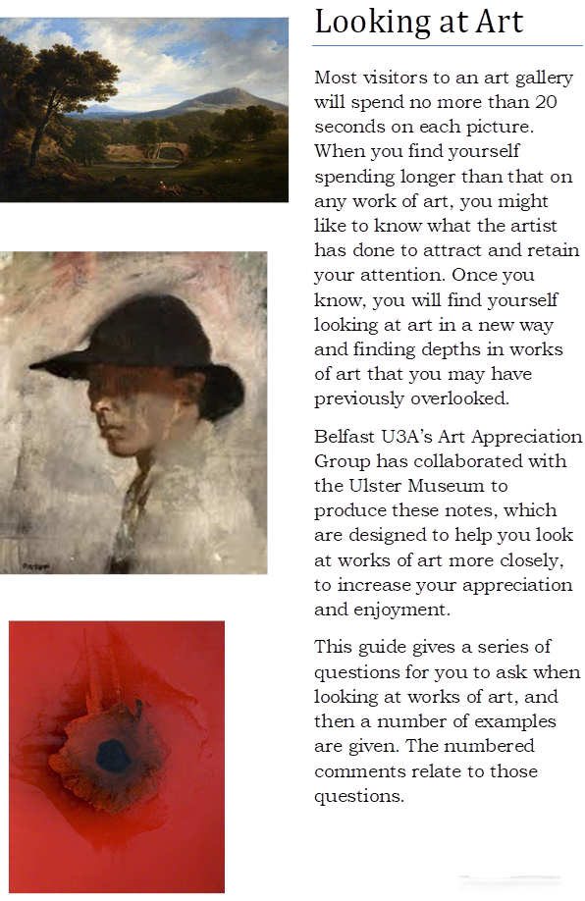

With thanks to National Museums NI and Belfast u3a Art Appreciation Group

James Arthur O’Connor 1793-1841
Scene in County Wicklow (1820)

This painting by James Arthur O'Connor, Scene in County Wicklow, is used as an example to put this framework into action. This is because it contains many of the elements and techniques used in landscape paintings.

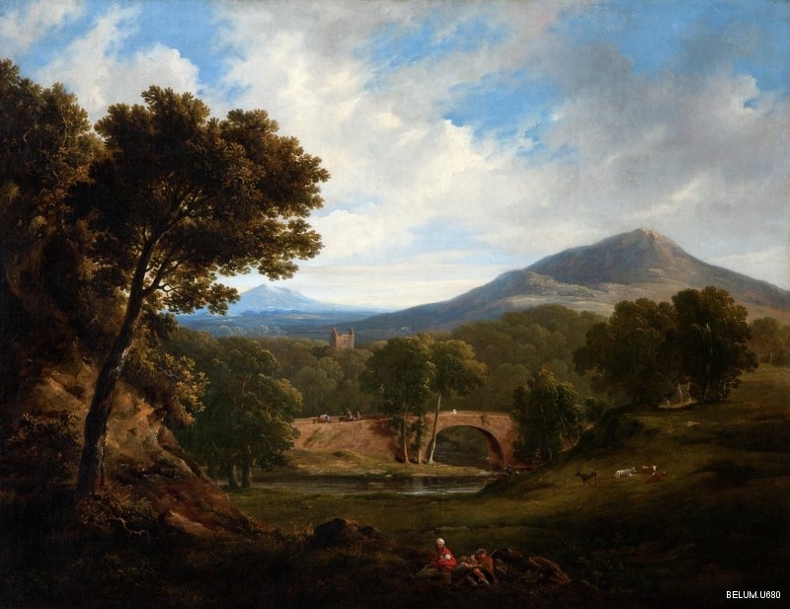
‘Courtesy of National Museums NI’

1. Eye Catchers The trees on the left are echoed by the copse of trees on the right and lead our eye onwards to those in the middle of the painting and beyond in the distance.The winding river leads our eye to the bridge, to the tower of the church and on to the mountains behind.

2. Colour and Tone.
See how the white of the cap and baby in the foreground leads your eye to the cows and on to the figure on the bridge.
The foreground colours are dark and warm, mostly browns. In the middle distance there are greens and lighter browns and in the distance, cool blues. This gives a sense of distance to the painting.
Note how the red draws your eye into the picture–would it look the same without it?

3. Technique
This is painted in oils, with very smooth delicate brush strokes.

4. Viewer Response
It is easy to imagine this painting in the home of a wealthy landowner. It shows a timeless and peaceful countryside.

John Luke
The Fox (1937)
John Luke was born in Belfast. He was known for the precision of his drawings and his use of tempera which he mixed himself.

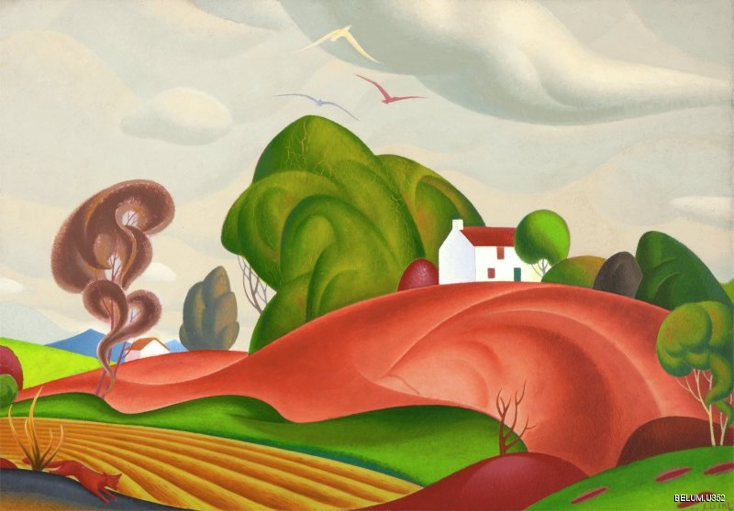
‘Courtesy of National Museums NI and The Estate of John Luke’

The Estate of John Luke

1. Eye Catchers
The landscape is painted with swirling shapes showing rolling hills, swirling clouds, tilled fields and trees. The fox of the title is just visible in the bottom left hand corner.
2. Colour and tone
The colours are rich and deep in tone. They create a story book impression of the landscape.
3. Technique
Very precisely drawn and carefully planned. It is painted using tempera (pigment mixed with egg white), creating a smooth texture.
4. Viewer response
This is a stylised picture. The swirling shapes of the hills are echoed in the shapes of the clouds and trees. This evokes a storybook landscape just right for imagining the story of the fox crossing the picture from left to right.
Roderic O’Connor
Field of Corn, Pont Aven (1892)
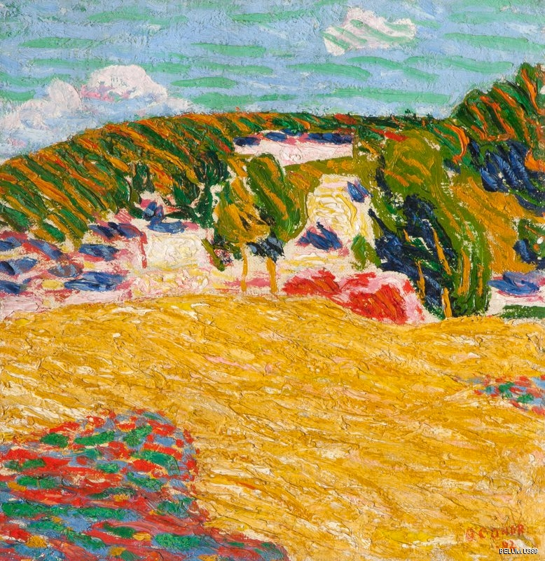
‘Courtesy of National Museums NI’

1. Eye Catchers
A field of corn, trees and hills are suggested by thickly applied paint. It is not entirely clear what some of the shapes represent – it is for the viewer to decide.

2. Colour and Tone
The most striking feature of this painting is the vibrancy of the colours. Note how complementary colours (such as red/green, blue/orange or yellow/purple) help to heighten the effect of the colours.

3. Technique
The paint is probably applied directly onto the canvas and mixed there, rather than on a palette. The brush handle may have been used to create the striations in the corn, indicating movement.

4. Viewer Response
The paint is very thickly applied; this produces shadows when viewed from the side and gives a feeling of movement in the corn.
The brightness of the colour and the thickness of the paint produce a feeling of exuberance.
This painting was ahead of its time, but O’Connor was not concerned about selling it as he was independently wealthy and so could afford to paint for his own pleasure.

Looking at .... Portraits

What is a portrait?

The word portrait has been said to derive from the French “trait pour trait” which means both ‘line for line’ and ‘trait for trait’. This neatly summarises two essential aspects of a portrait, it should resemble the sitter’s external appearance accurately ‘line for line’ but also show their internal character ‘trait for trait’.

A portrait is like a piece of theatre. The costume, props and staging can tell you much about the sitter and the artist. These guidance notes use a theatrical framework and aim to help you get a richer experience when you look at portraits.

- Staging
- Costume: What is the sitter wearing - a uniform, best or casual clothes, fancy dress, jewellery?
- Props: What is the sitter holding? What other objects are shown in the portrait?
- Scenery: Where has the painter placed the sitter?

- Character
- Is the ‘sitter’ sitting or standing?
- What does the sitter's body language tell you (relaxed/uncomfortable)?
- What aspects of the sitter's character can you infer from the portrait?
- Where is the sitter looking?

- The Artist
- What materials (media) has the artist used?
- What type of brush strokes has the artist used, is the paint thick with bold brush strokes or smooth with finer brush strokes?
- What colours are used and why?
- How has the artist used symmetry, lines and shapes to convey character?
- Are there repeat patterns (echoes) in the portrait?

- Viewer Experience
- Is the sitter close or distanced from you the viewer?
- Does the portrait evoke an emotional reaction/feeling in you?

Group Portraits
When looking at group portraits the above framework is relevant. But in addition, look at the positioning of each person in the group and what that tells you of the relationships between them.

Edward McGuire (1932 -86)
Portrait of Seamus Heaney 1939 – 2013 (1974)
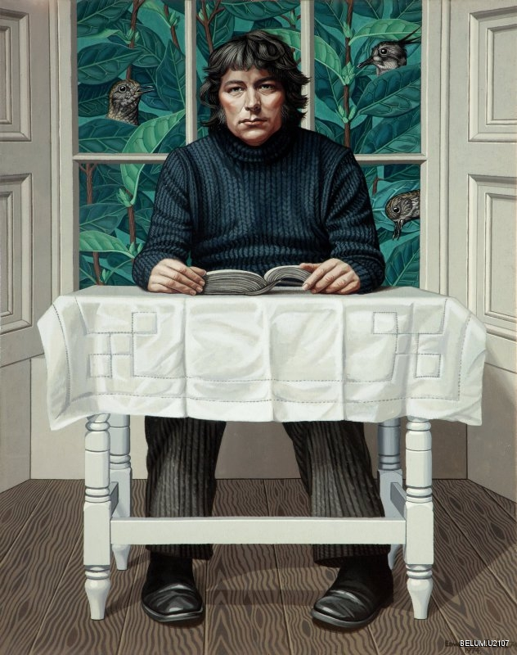
‘Courtesy of National Museums NI’

1. Staging
The sitter is wearing neutral clothes that are hard to date and that do not distract. (Heaney himself said these were clothes he had never owned.)
The book, table and tablecloth are the only props and they sit between the sitter and the viewer. The formal country house setting and the view of birds and leaves outside the windows give a slightly surreal atmosphere to the portrait. Maguire said the leaves were privet painted large.

2. Character
This portrait is a good physical likeness of a younger Heaney. What is Heaney seated on? Does he seem cramped? The odd setting, the apparent lack of a seat, may suggest depth and mystery, a man not easily read.

3. The Artist
Fine exact brush strokes, with a slightly surreal dimension in the background, are typical of Maguire's work. He kept stuffed birds in his studio. The foreground colours are restrained, with strong forceful colours in the giant privet outside the window, perhaps suggesting the sitter's rich interior life. Patterns of lines and squares appear throughout the painting, in the sitter's clothes, floor boards, table, tablecloth and window. The portrait is not symmetrical, although it first appears so, with the sitter placed slightly to the right- hand side.

4. Viewer Experience
Does the sitter look you in the eye, or stare through you? He maintains distance with the table and book in between. The portrait evokes a sense of dignity, of reserve, of a man of depth with a rich interior life and a depth of feeling for nature.

William Orpen 1878-1931
Self Portrait painted 1905-10

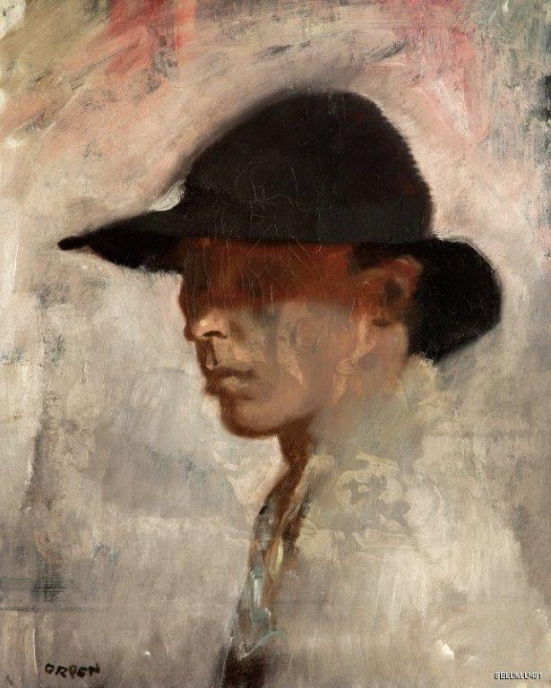

‘Courtesy of National Museums NI’

1.Staging
The background is vague and indistinct. The only object in the painting is the artist’s hat which shades his eyes. The artist has placed himself in a nondescript unidentifiable place, a nowhere almost.

2.Character
This painting is a good likeness, although the eyes, the mirrors of the soul, are not shown. The sitter’s face is sideways on to the viewer although his shoulders are almost turned away. From the posture and the hidden eyes the painting conveys a private man who reveals little of himself.

3.The Artist
The artist uses bold brush strokes that are clearly visible. All outlines appear to be blurred apart from the nose and lips which are painted in fine detail (the artist considered himself ugly and particularly disliked his slightly protruding lower lip). The use of light is intriguing, the lower face and shoulder reflect light from the right hand side but no light appears on the hat, it seems to soak up the light and is a very striking flat black shade. The curves of the hat are echoed in the curve of the shoulders; the colour of the jacket is echoed in the background colour; and there are balancing uses of red/pink at the top of the portrait.

4.Viewer Experience
The sitter looks away from the viewer, his eyes are not shown, making it difficult to get a sense of the man. While the sitter is close to the viewer the style of the painting creates a sense of distance. William Orpen was an official war artist during World War I, and was deeply affected by the horror of what he saw. This painting appears to convey a man apart from the everyday world keeping his own secrets and experiences close.
Francis Stuart (1902-200)
Neil Shawcross (b 1940) 1978

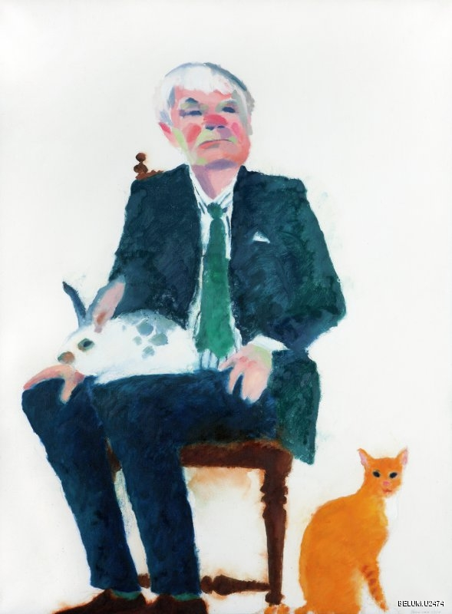
‘Courtesy of National Museums NI’

1.Staging
A chair and two animals, nothing to identify place. The sitter wears a plain business suit and a regular shirt and tie. The background is absolutely plain, it reveals nothing.

2.Character
The painting is a good likeness of the sitter. His body language seems relaxed although the posture is unusual with the position of the legs similar to those in Egyptian wall paintings. The hard chair suggests a formal rather than a relaxed posture. The firm chin conveys a strengh of character, almost a stubbornness that contrasts with the softness of the rabbit on his lap and the inquisitive and open gaze of the cat.

3.The Artist
Oil on canvas with a deliberate blurring of lines and thick blocks of contrasting colour on the face (the eyes, cheeks and nose particularly). The artists uses a limited colour palette, yet the painting appears colourful. The painting conveys a sense of balance through the two contrasting animals, the leg of the chair under the left hip and the chair post over the right shoulder.

4.Viewer Experience
The sitter’s eyes are hard to see, and he appears to look away from the viewer. Intriguingly both animals stare directly at the viewer. The sitter is close to the viewer, although the two animals form a slight barrier. The viewer is left with a sense of a man of firm opinions unafraid to show a softer side.

The Family of Thomas Bateson, Esq. (1705–1791)
Strickland Lowry (1762)

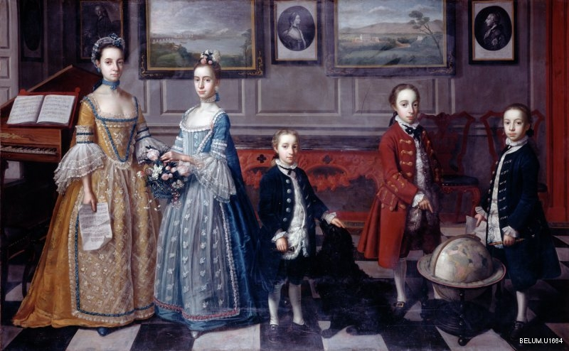
‘Courtesy of National Museums NI’

1.Staging
This portrait of the Bateson children is a fascinating record of the interior of the Bateson home at Orangefield, Co. Down, near Belfast. The clothing, the furnishings, the wall paintings all convey wealth and prosperity.

2.Character
It is not possible to tell if this 1762 portrait captures a true likeness of the sitters. The five children are standing in what to 21st century eyes is an unimaginative line up. The portrait tells little of the character of the five unsmiling children but much of the wealth of their family.

3.The Artist
The brush strokes of the oil painting are fine and show great detail. The artist uses light to show the five children in great detail with their clothing and background furnishings receiving an equal attention to detail. The two groupings show the standard accomplishments expected of girls and boys of that era, the girls in pretty dresses with an interest in music, literature and flowers and the boys with animals, world issues and perhaps trade/ travel. The repeated wall panels in the background and the landscapes and silhouettes echo each other as do the chequerboard squares in the floor.

4.Viewer Experience
All five children look straight at the viewer. They stand close to the viewer but their expressionless faces have no emotional depth. The positioning of the two girls suggests a close relationship between them, but the three boys each stand separately perhaps suggesting the independence they will be expected to achieve on maturity. The viewer is left with a sense of the Bateson’s prosperity rather than a sense of the children’s personalities. Perhaps to the 18th century viewer this portrait conveyed more of the children’s personalities.

Looking at …. Abstract Paintings

Many of us are at a bit of a loss when it comes to looking at abstract paintings. We may find it hard to understand what the painting means or what it is trying to represent and may feel a bit inadequate when we fail to come up with any answers.

The first bit of advice is DON’T PANIC!

It may help to know a bit about the context in which abstract art developed. Before the advent of photography in the middle of the 19th Century, artists treated canvases like a window through which the world was represented. After the advent of photography, however, the need for a visual record through painting no longer existed and artists began to experiment with ways of using the flat surface of the canvas to create different effects.

Instead of asking what an abstract painting means, or what the artist intended, it is perhaps more useful to ask ourselves how a painting makes us feel and what it is about the painting that makes us feel that way. How is our eye drawn across the surface of the canvas?

Some things to look out for are:

- Colour
- What colours are used by the artist – are they complementary/analogous? (see colour wheel below)
- Do the colours used have an effect on how you feel?
- How are the colours applied – is the paint built up in layers and if so what effect does this have?

- Subject matter
- Does the title give any clue as to what the painting represents, if anything? Often abstract paintings are either untitled or identified by titles which do not offer any clues – often a number or a date. This underlines the point that the painting is not intended to represent anything we can relate to.
- Are there any recognizable objects in the painting and if so, what is their treatment by the artist? Are they distorted? Or ‘flattened’? Fragmented?
- Can you see shapes or patterns in the painting?
- Are shapes or patterns echoed in different parts of the painting?
- What draws your eye to the painting – what do you see first, and how is your eye drawn to different parts of the painting?
- Is there a sense of balance to the painting, either through form or colour?

- Viewer Response
- How do you feel when looking at the painting – could you live with it?
- Does it look different if you view it from a distance?
- What about the size of the work? Does it over or underwhelm you? Was it commissioned for a public area?
- Do different shapes have different emotional overtones, for example, shapes with curves are enfolding and protective, whilst those with straight lines are strong and inflexible. What is the effect of combining these different types of shapes?

- Process
- How important to the painting is the way in which it was created?
- Has it been carefully constructed or is there an element of chance in the way the paint was applied?

Understanding Colour
A colour wheel of the sort used by artists is composed of the three primary colours, red, blue and yellow. In between these are the secondary colours that are produced by mixing the two adjacent primary colours together (for example green between yellow and blue). Colours which are opposite each other on the colour wheel are known as complementary and these colours create the most contrast. Colours which are adjacent to each other on the colour wheel are referred to as analogous and putting them together creates a harmonious effect, pleasing to the eye.
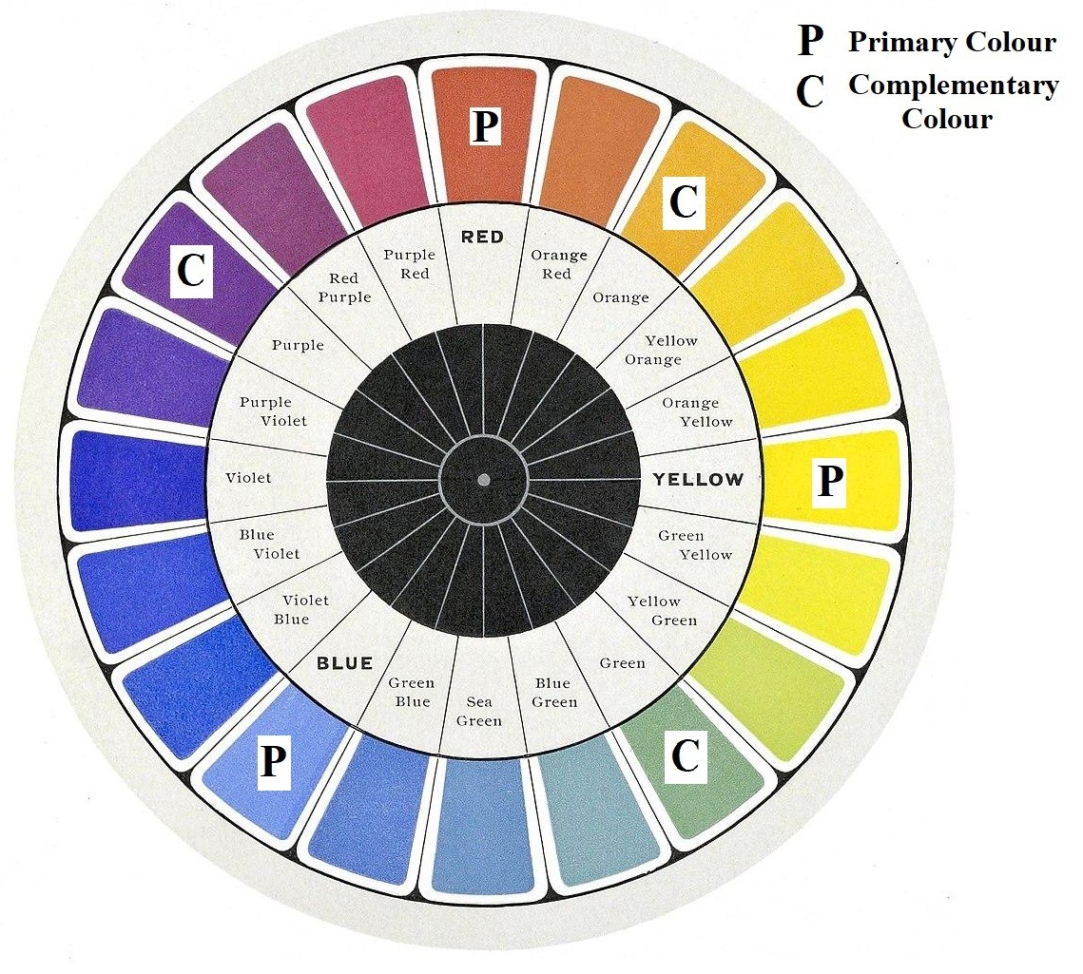

Modern towards Abstract

Mainie Jellett (1897-1944) was one of the first artists to introduce abstraction to the Irish art scene. By looking at examples of her work, over a span of years, we can see her progression from modern towards abstract art.

This was painted early in Jellett’s career when she was taking art classes from William Orpen in Dublin.

Still Life (1914 -1916) - see below
1. Colour
There is a pleasing use of complementary colours.

2. Subject Matter
The subject matter is familiar as ordinary kitchen objects.

3. Viewer Experience
The subject matter is recognisable as kitchen objects.

4. Process
This is a departure from the normal laws of perspective and a flattening out of three-dimensional shapes. There is a balance of curves with straight lines that creates a harmonious composition.
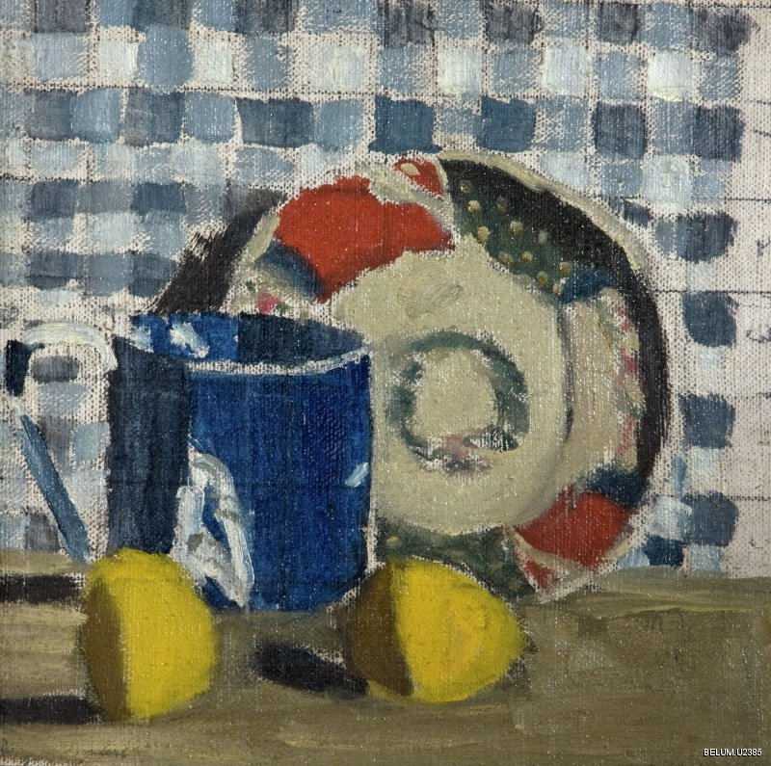

‘Courtesy of National Museums NI’

Seated Female Nude (1922)
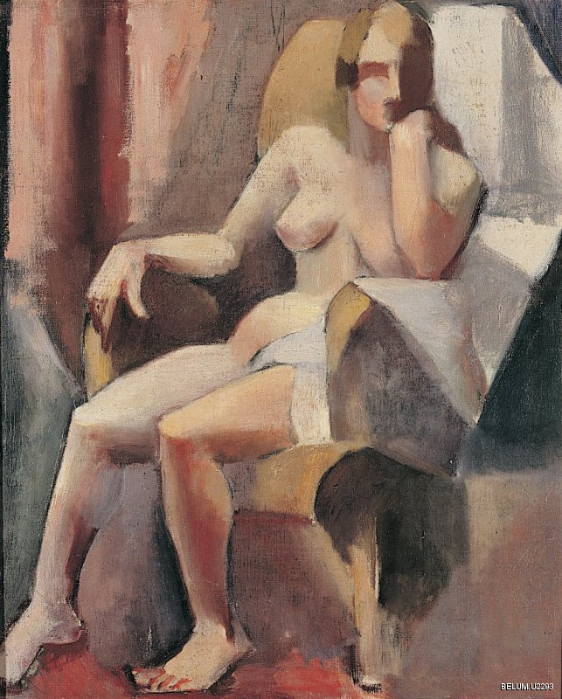
‘Courtesy of National Museums NI’

By 1922, at the time Nude was painted, Mary Jellett was living and working in Paris and under the tutolage of Albert Gleizes and was experimenting with the principles of cubism.
1. Colour The colour palette is limited.

2. Subject Matter The Nude is realistic and instantly recognizable.

3. Viewer Experience The Nude is easily recognisable with warm skin tones.

4. Process The principles of perspective are rejected and have become unimportant. The image is reduced to geometric forms which are then fractured and seen from multiple viewpoints. The figure is simplified and made up of stylized blocks of colour. The warmer skin tones are echoed in the background fabric and the white highlights drawing the eye from the top of the chair down the right hand side of the figure. Look out for echoes of curves also in the lines of the body and chair.

With many thanks to National Museums NI and The Estate of John Luke, copyright holders, and to Belfast u3a Art Appreciation Group
Welcome | National Museums NI

All images included in this guide are strictly copyright and under no circumstances should be used other than in this format as a u3a Learning Resource.

mike.carr@subjectadviser.u3a.org.uk

u3a - Subject Advice



August 2025

